Use Case Diagram

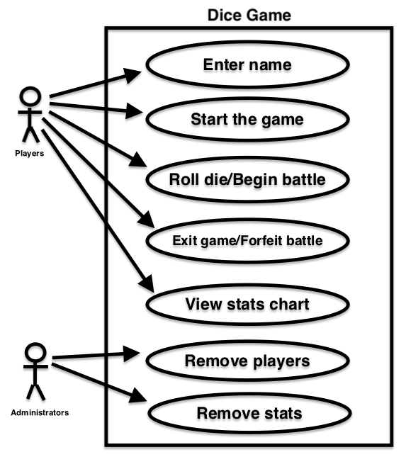

User Stories

1. As a player, I want to enter my name so that I can distinguish my total score from other players’.
2. As a player, I want to start the game so that I can begin battling my opponent.
3. As a player, I want to roll the die/begin the battle so that I can attack my opponent, effort to garner points, and make them faint.
4. As a player, I want to exit the game/forfeit the current battle so that I can choose when I no longer want to play the game.
5. As a player, I want to view the stats chart so that I can see how I rank amongst past players.
6. As an administrator, I want to remove players so that if their name is inappropriate I can get rid of it.
7. As an administrator, I want to remove stats so that if a player’s stats are inappropriate I can get rid of it.